**Week 6**

**3.ReactJS – HOL**

**FILE STRUCTURE  
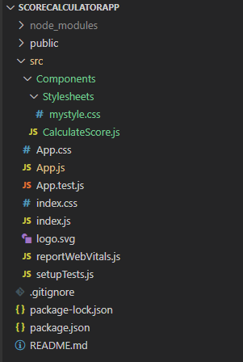**

**CODE**

*C:\Users\User\Desktop\scorecalculatorapp\src\Components\CalculateScore.js*

import './Stylesheets/mystyle.css'

const percentToDecimal = (decimal) => {

    return (decimal.toFixed(2) + '%')

}

const calcScore = (total, goal) => {

    return percentToDecimal(total/goal)

}

export const CalculateScore = ({Name, School, total, goal}) => (

    <div className = 'formatstyle'>

        <h1> <font color = "Brown"> Student Details: </font> </h1>

        <div className = "Name">

            <b> <span> Name: </span></b>

            <span>{Name}</span>

        </div>

        <div className = "School">

            <b> <span> School: </span></b>

            <span>{School}</span>

        </div>

        <div className = "Total">

            <b> <span> Total: </span></b>

            <span>{total}</span>

            <span>Marks</span>

        </div>

        <div className = "Score">

            <b>Score:</b>

            <span>

                {calcScore(

                    total,

                    goal

                )}

            </span>

        </div>

    </div>

)

*C:\Users\User\Desktop\scorecalculatorapp\src\Components\Stylesheets\mystyle.css*

.Name

{

    font-weight: 300;

    color : blue;

}

.School

{

    color : crimson;

}

.Total

{

    color : darkmagenta;

}

.formatstyle

{

    text-align : center;

    font-size: large;

}

.Score

{

    color : forestgreen;

}

*C:\Users\User\Desktop\scorecalculatorapp\src\App.js*

import logo from './logo.svg';

import './App.css';

import { CalculateScore } from './Components/CalculateScore';

function App() {

  return (

    <div>

      <CalculateScore Name = {"Steeve"}

      School = {"DNV Public School"}

      total = {284}

      goal = {3}

      />

    </div>

  );

}

export default App;

**OUTPUT**

